

Developer Guide

Marine Delivery Application

Version 1.1

Oct 14th, 2019

Revision History

|  |  |  |  |
| --- | --- | --- | --- |
| **Date** | **Version** | **Author** | **Revision Notes** |
| 10/14/2019 | 1.0 | Sonu Sam Joseph | Baseline Draft |
| 10/16/2019 | 1.1 | Saipriya M | Formatted |
|  |  |  |  |
|  |  |  |  |
|  |  |  |  |
|  |  |  |  |
|  |  |  |  |
|  |  |  |  |
|  |  |  |  |

Table of Contents

Marine App Development Guide 1

Marine Development Setup 1

Testing on Device 2

Build Generation 5

QA Release 5

Production Release 6

Debugging 7

Chrome Development Tools 7

Attachments and Logs 8

Marine Attachments 8

Marine Logs 9

# Marine App Development Guide

## Marine Development Setup

1.Install the latest version of nvm using setup zip from

<https://github.com/coreybutler/nvm-windows/releases>

2.Install node version 6.14.2

nvm install 6.14.2

3.Install ionic version 1.7.16

npm install -g [ionic@1.7.16](mailto:ionic@1.7.16)

4. Install cordova version 8.0

npm install -g [cordova@8.0](mailto:cordova@8.0)

5.Clone the Marine Delivery Repository from BitBucket

<https://bitbucket.org/pdisoftware/marinedeliveryapp>

6.Checkout branch ‘develop’

7.Add gulp

npm install -g gulp

8.Run ionic serve to see App running on Google Chrome

ionic serve

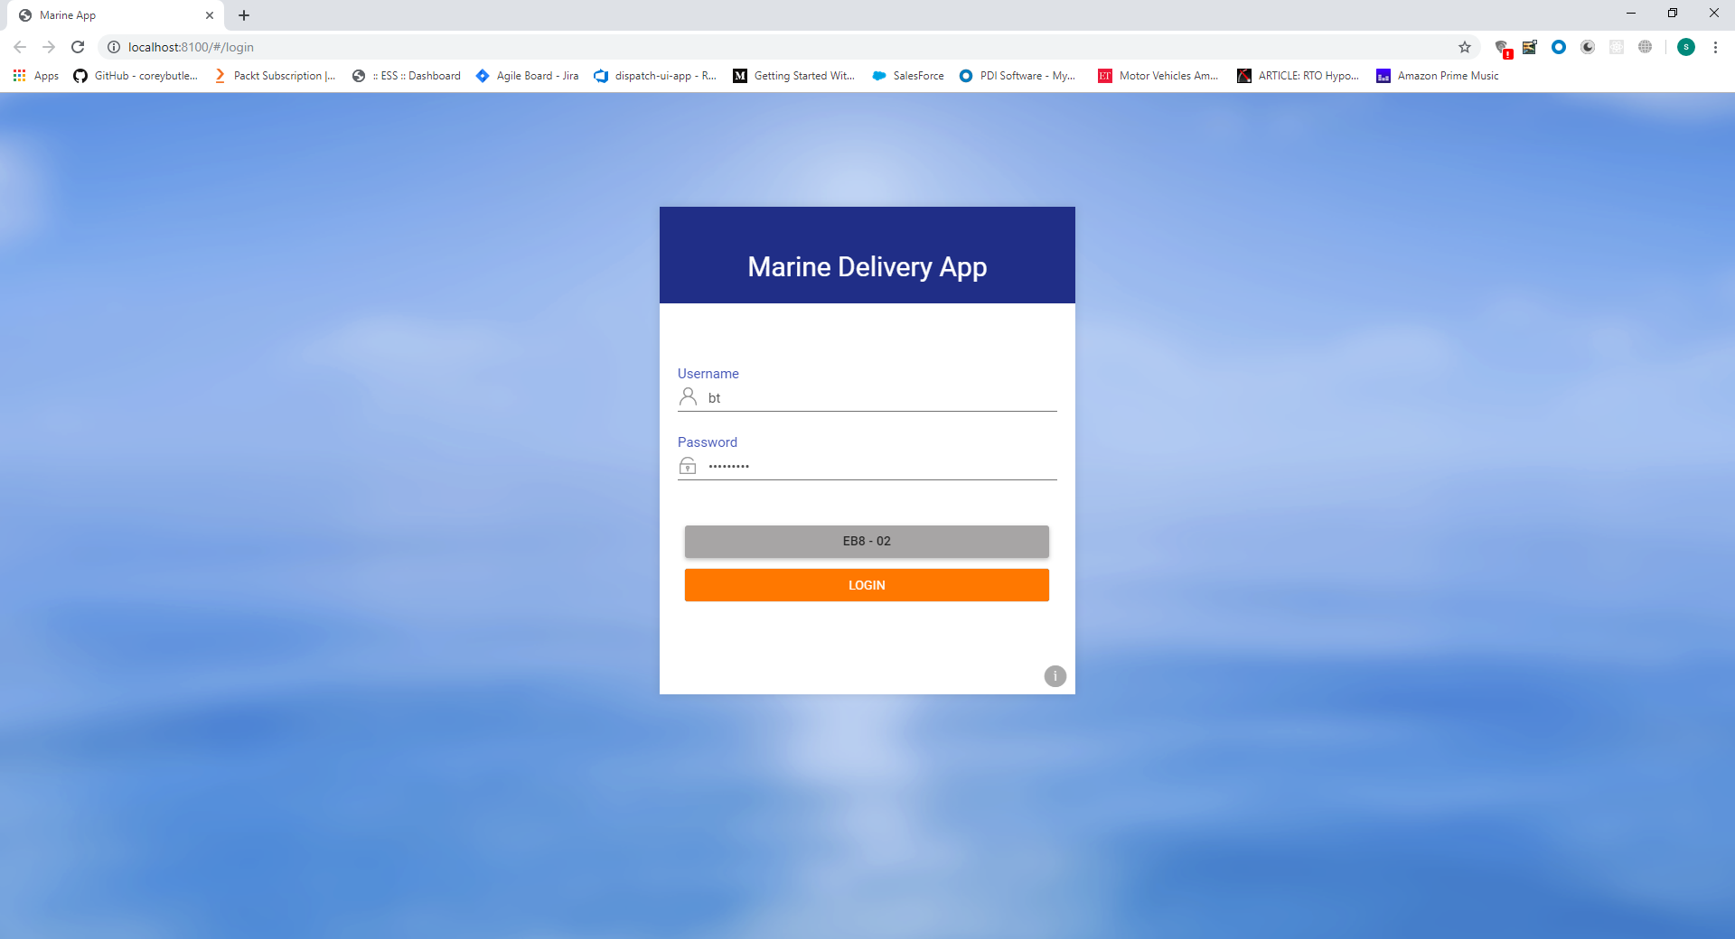

## Testing on Device

1.Install version 3. 4 of Android Studio from <https://developer.android.com/studio/archive>

2.Set Android home environment variable and add ANDROID_HOME,jre to User Path and platform tools to system path

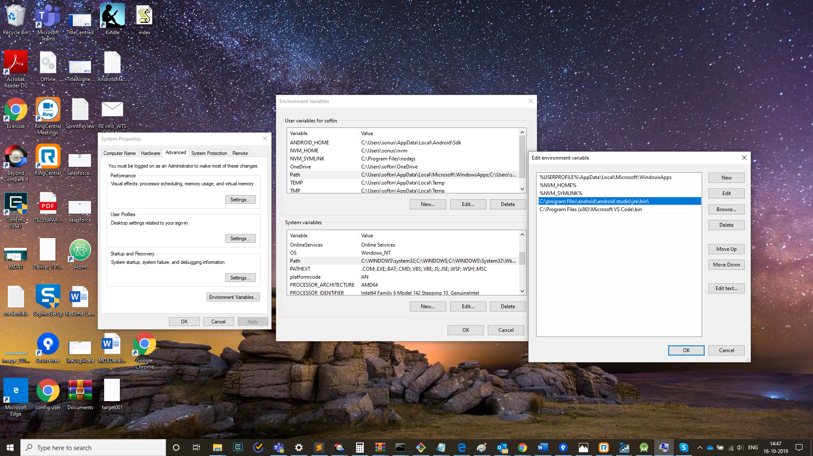

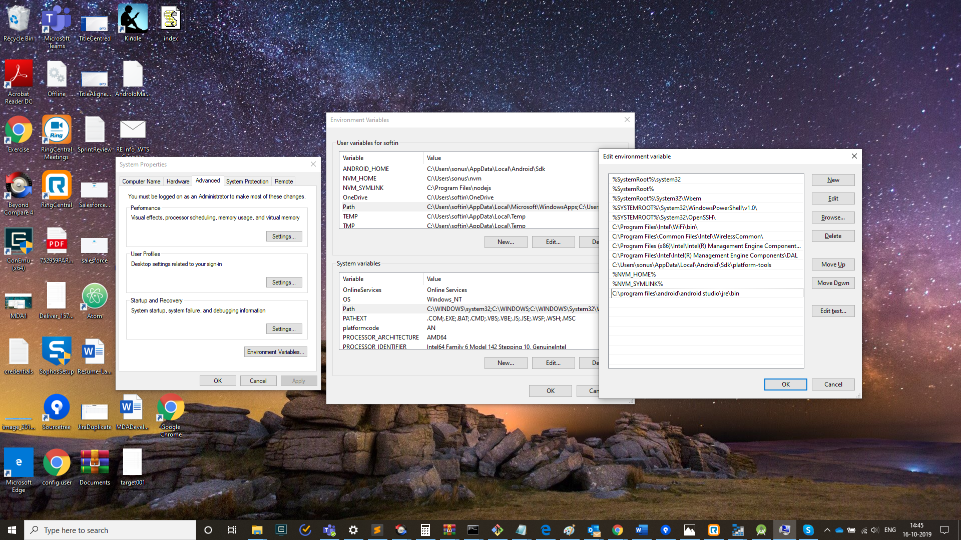

3.Open Android Studio and Open Android SDK Manager

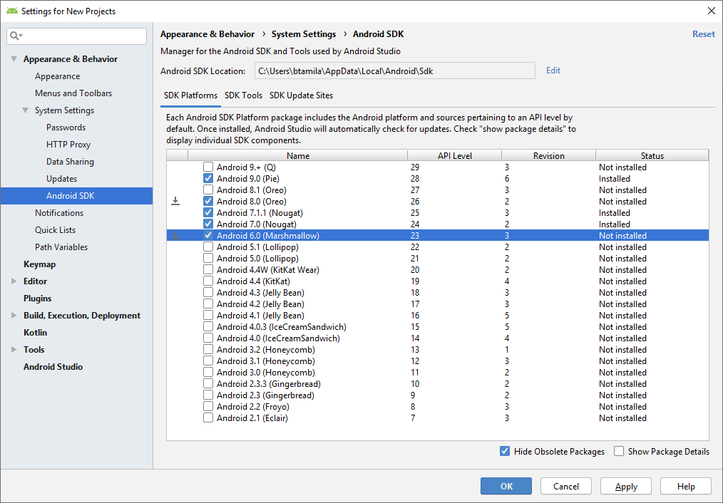

4.Install Android SDK packages from 6 to 8

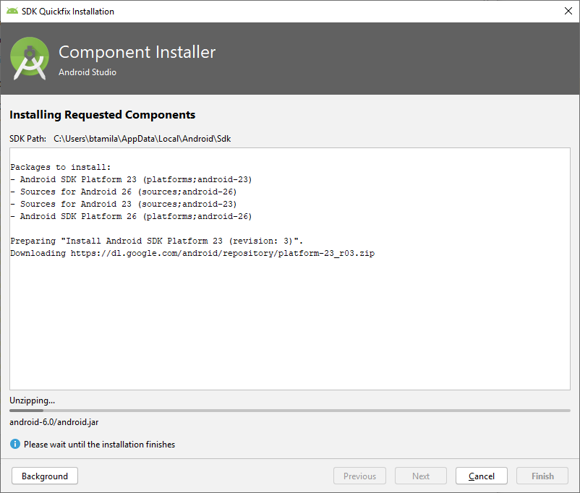

5.Connect Android device through USB

6.Test on device

ionic run android

7.Application should appear on the device

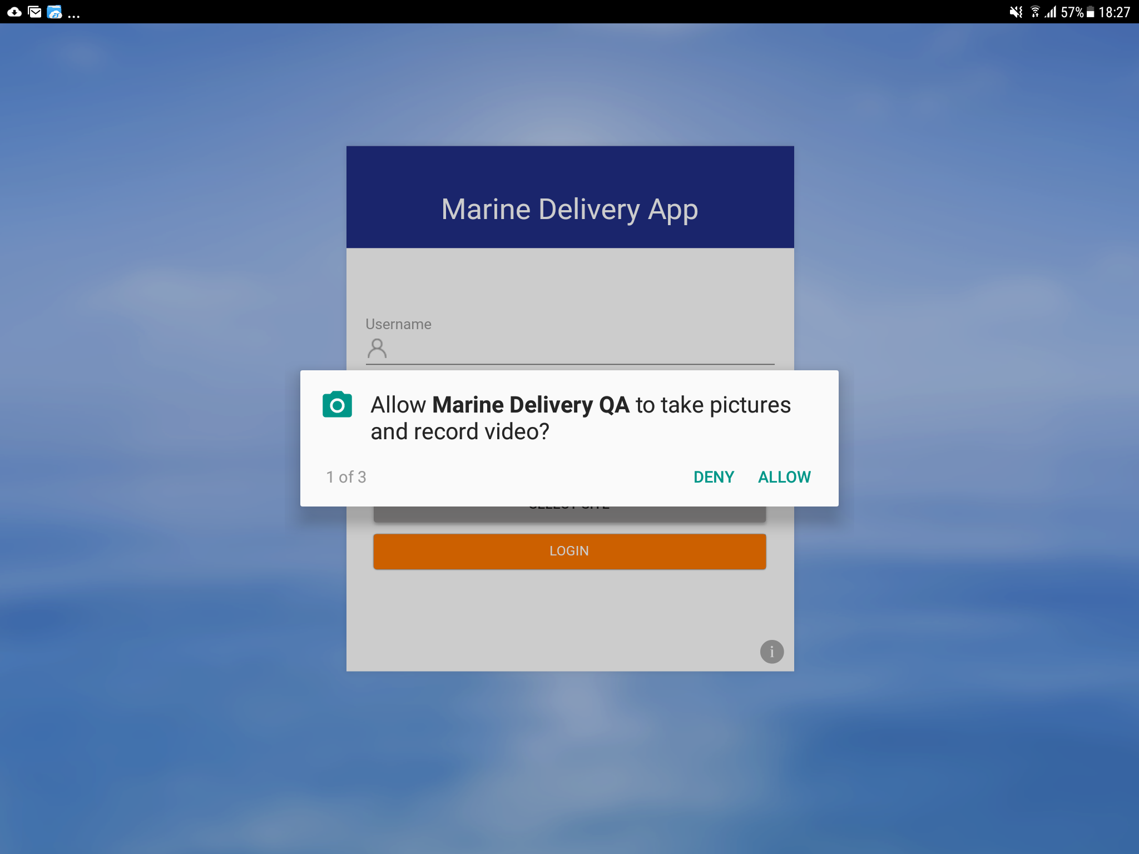

## Build Generation

## QA Release

1.Increment version number in qaconfig.xml file located in \qa folder

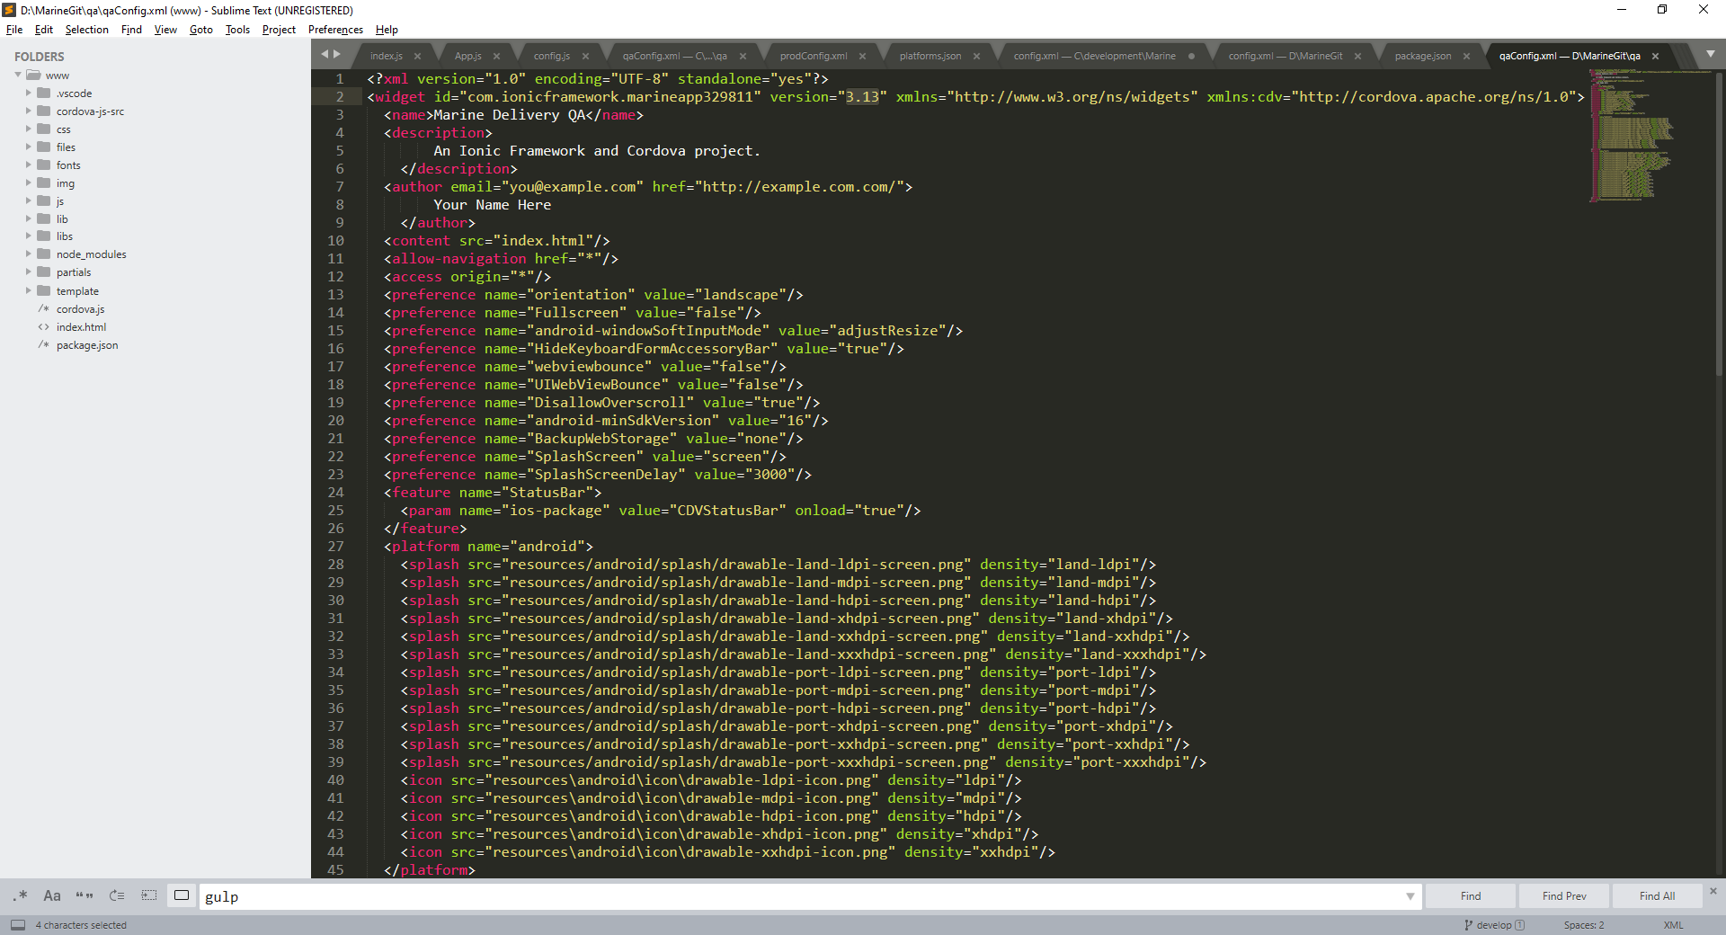

2.Build QA version of app

gulp buildQa

3.Built will be located with current date in qa folder

## Production Release

1.Increment version number android-versionCode in prodconfig.xml file located in \prod folder

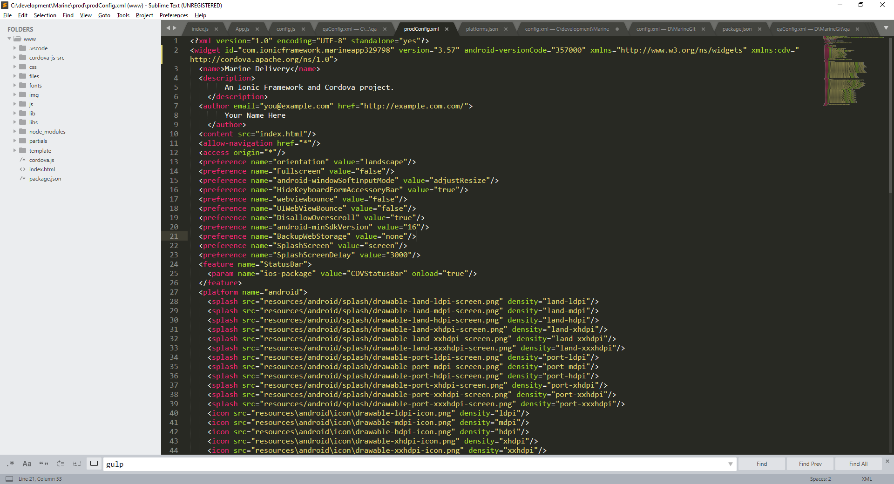

2.Build Production version of the app

gulp buildProd

3.Built APK will be located with current date in \prod folder

## DEBUGGING

## Chrome Development Tools

1.Make sure that the stetho plugin is installed

2.Connect Android device through usb cable

3.Open Google Chrome

4.Use the Inspect Option

chrome://inspect

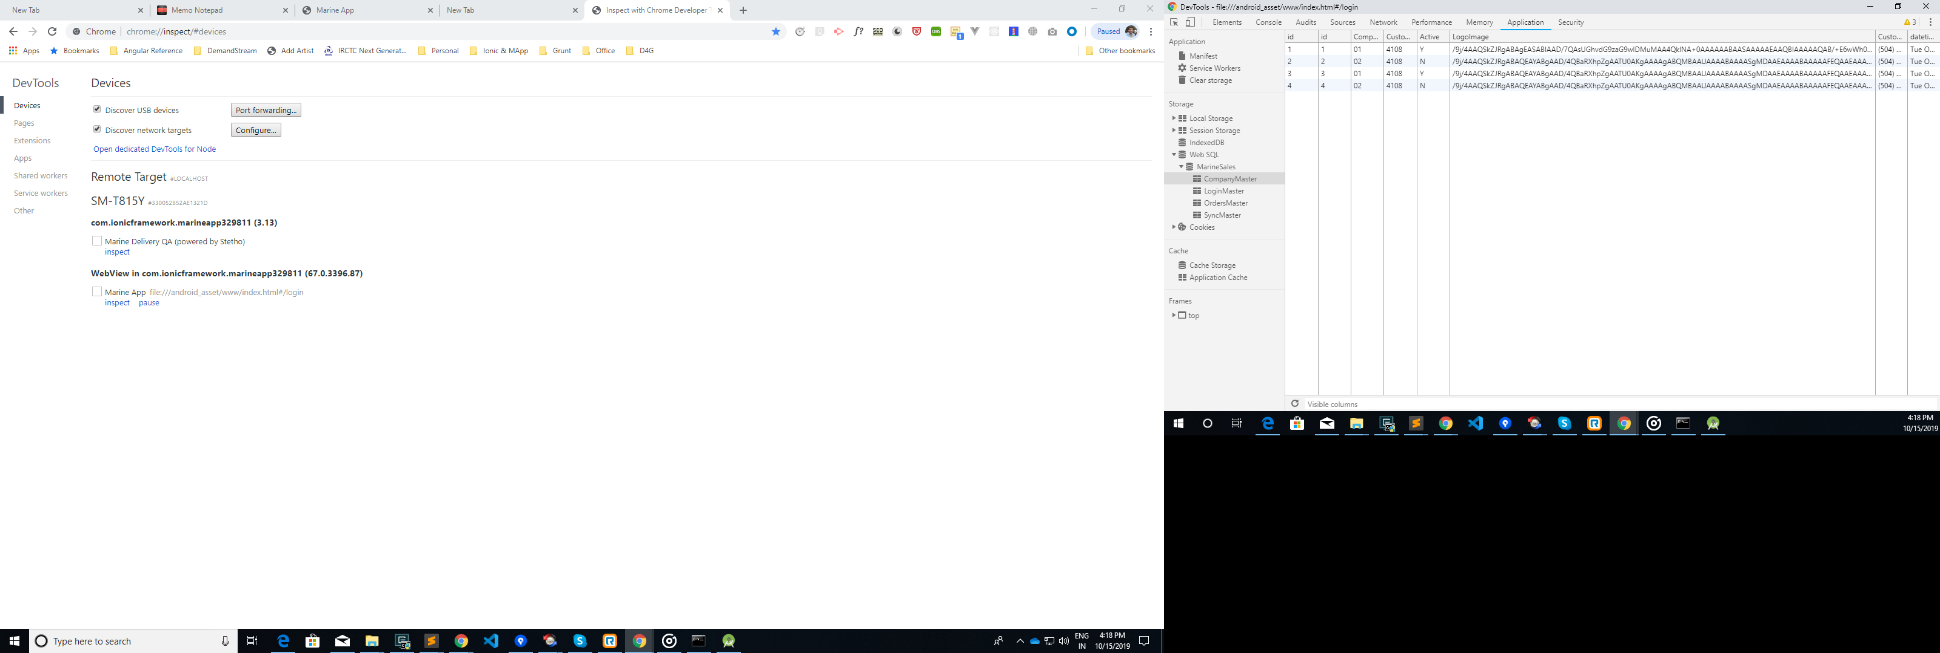

## Attachments and Logs

## Marine Attachments

All the attachments of each order will be stored locally in the device. In case if we want the view or share the document, then we can view the same in below location.

The Internal Storage -> Marine Attachments -> Folder will be created as per the Order No (Say SA001) -> Inside the Folder following documents will be stored.

* Shipment DOI
* Delivery DOI
* Meter Ticket
* Image attachments
* PDF Documents Attached
* Deliver Ticket

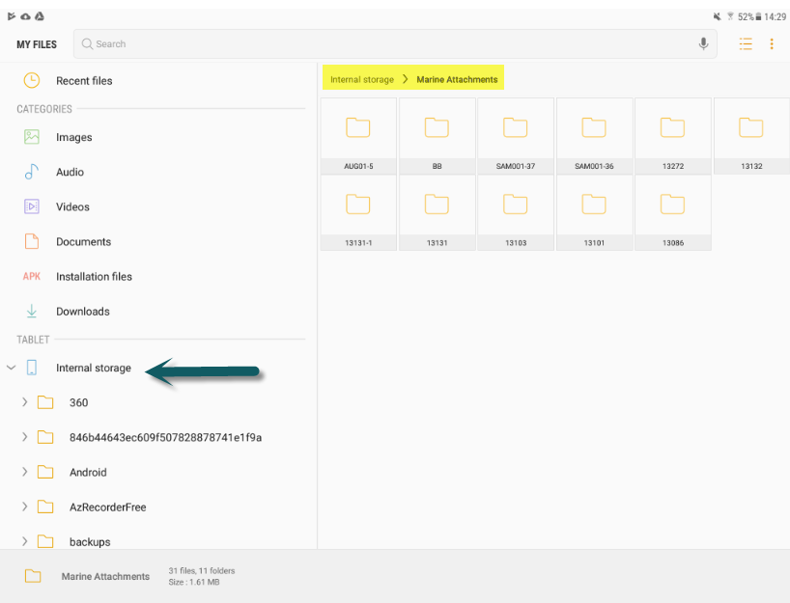

## Marine Logs

The Logs of each order will be stored locally in the device. In case if we want the view or share the Log files, then we can obtain the same in below location.

The Internal Storage -> Marine Logs -> Folder will be created as per the Order No (Say SA001).

